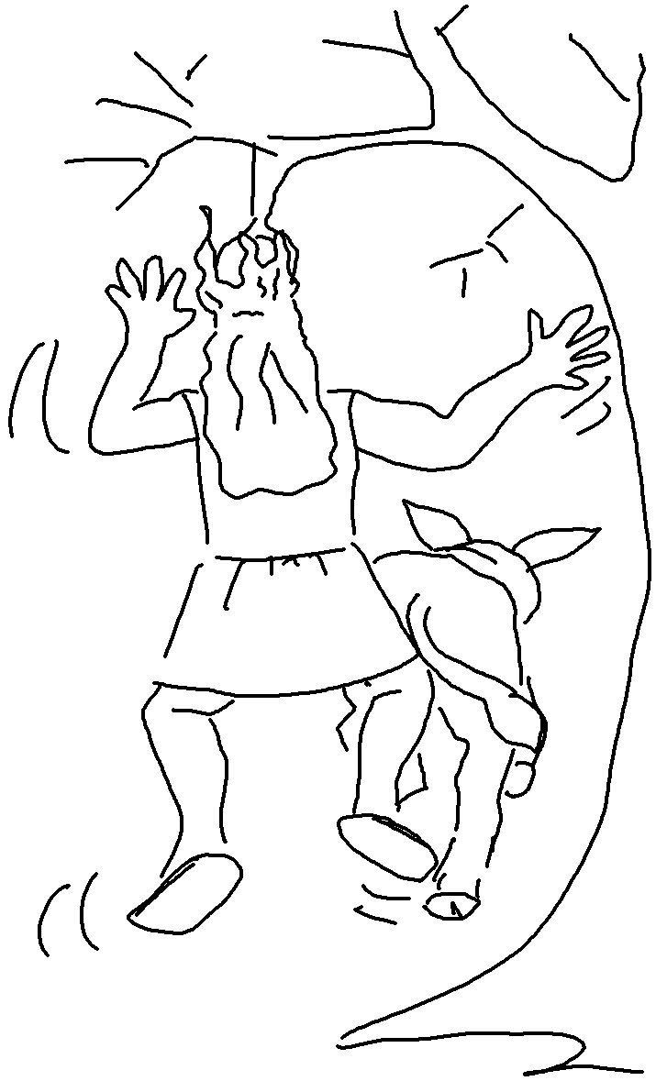

Children, obey your parents… for this is right…
Ephesians 6:1_{NIV}

